Unearthing The Environmental Impact Of Human Activity:

A Global CO2 Emissions Analysis

INTRODUCTION:-

Overview:

* Analysing Global Co2 Emission across countries from 1975 to 2020. This dataset contains a record of Co2 Emission by each Country and Region of Earth, here we are going to analyse and visualise Country wise, Region wise and Overall Co2 Emission on Earth.
* CO2 emissions are emissions stemming from the burning of fossil fuels and the manufacture of cement; they include carbon dioxide produced during consumption of solid, liquid, and gas fuels as well as gas flaring.
* CO2 analysis is important for understanding and mitigating the impacts of climate change, as CO2 is a greenhouse gas that contributes to global warming. It is also used in industries such as food and beverage production, where monitoring CO2 levels is critical for quality control and safety.

Purpose:

* Climate change research: CO2 analysis is essential for measuring atmospheric CO2 concentrations and monitoring changes over time. This data is critical for climate change research and for understanding the impact of human activities on the environment.
* Indoor air quality: CO2 analysis can be used to monitor indoor air quality in buildings, schools, and other enclosed spaces. High levels of CO2 can indicate poor ventilation and can lead to health problems such as headaches and fatigue.

* Greenhouse gas emissions: CO2 analysis can be used to measure emissions from industrial processes, power plants, and transportation sources. This data is important for understanding the impact of human activities on the environment and for developing strategies to reduce greenhouse gas emissions.

* Food and beverage production: CO2 analysis is critical for the production of carbonated beverages, where the correct amount of CO2 is needed to ensure product quality and safety.

* Environmental monitoring: CO2 analysis can be used to monitor CO2 levels in soil, water, and other environments. This data can provide valuable insights into ecosystem health and can help identify areas where CO2 emissions need to be reduced.

PROBLEM DEFINITION AND DESIGN THINKING:-

Empathy Map:

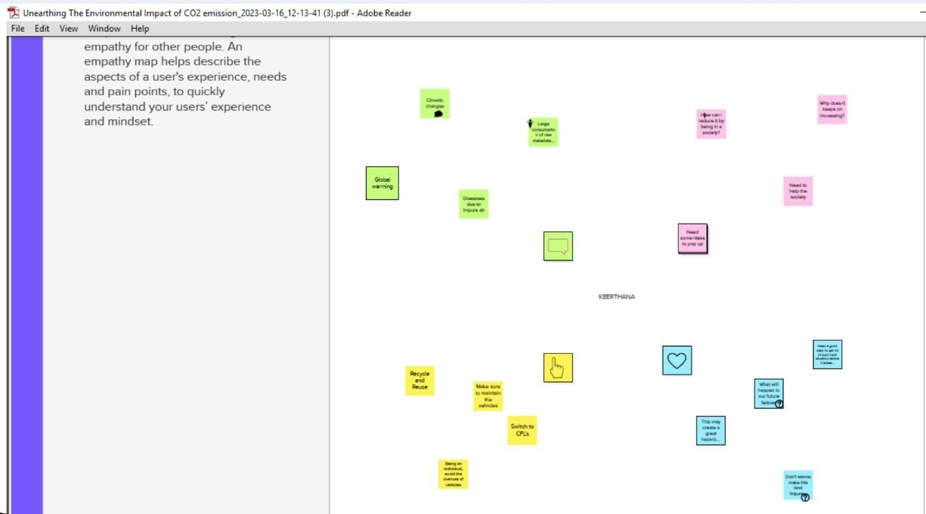

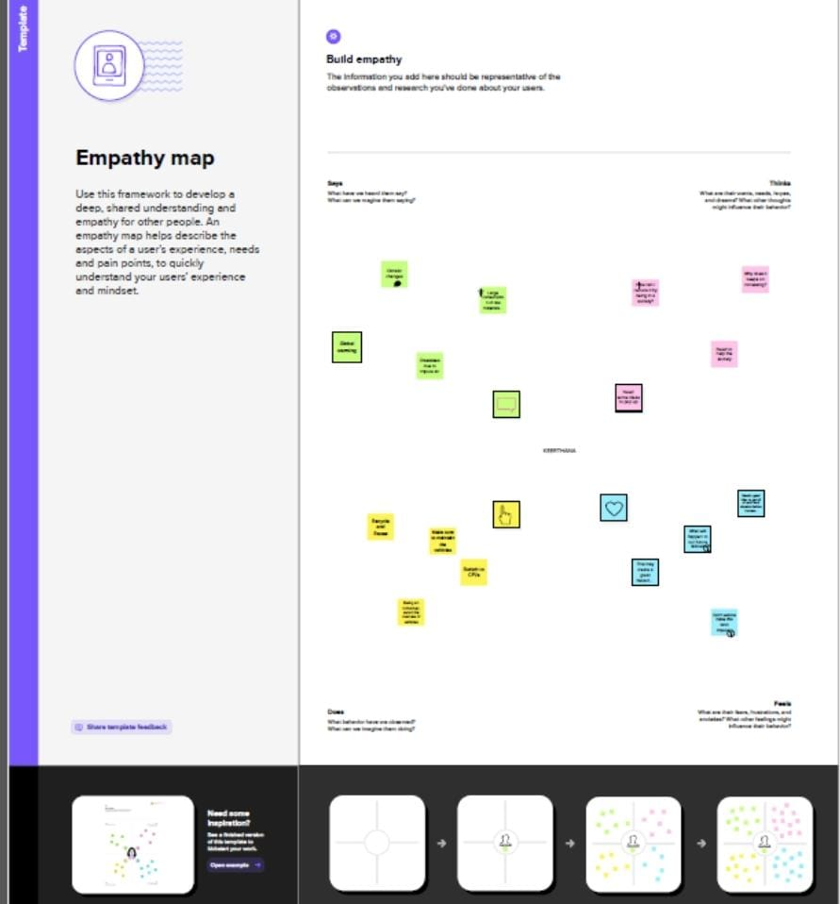

Ideation And Brainstorming Map:

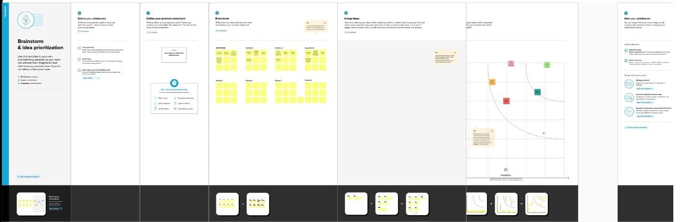

RESULT :-

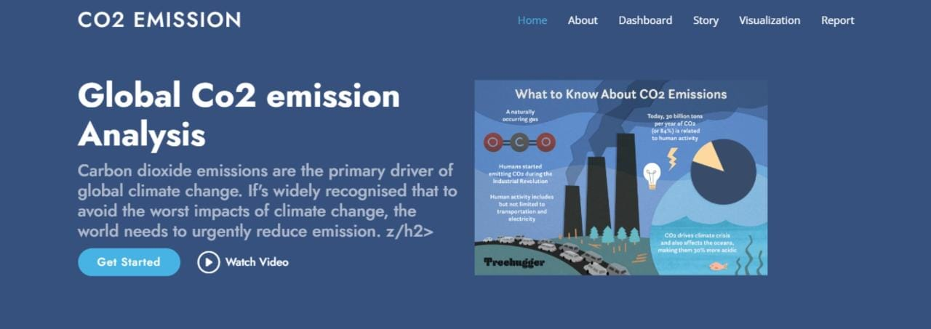

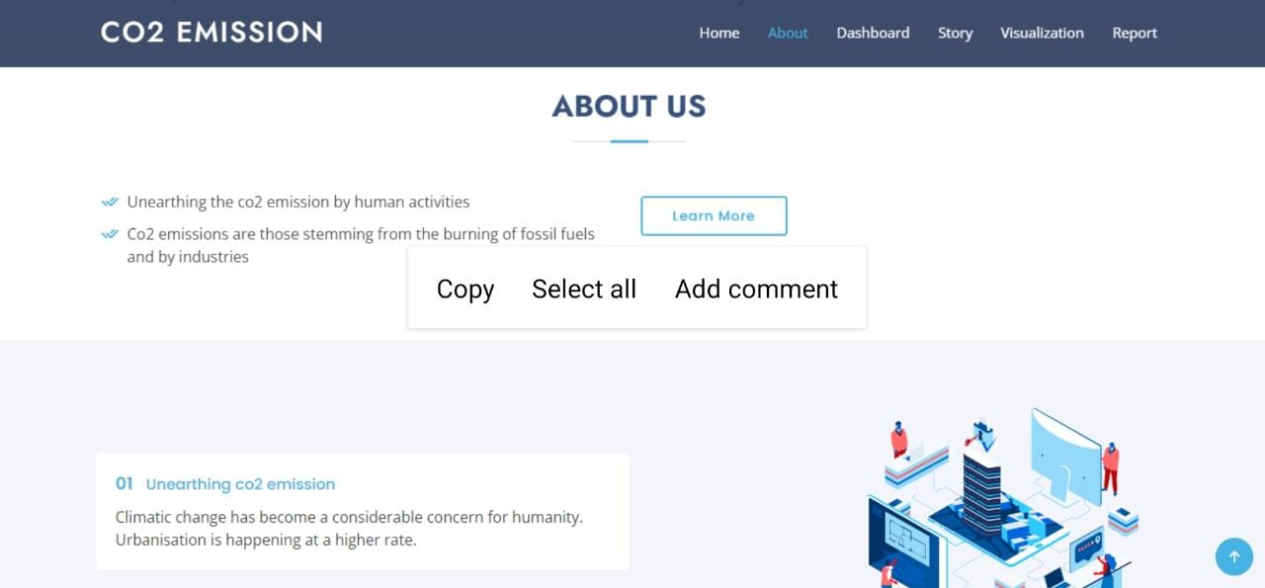

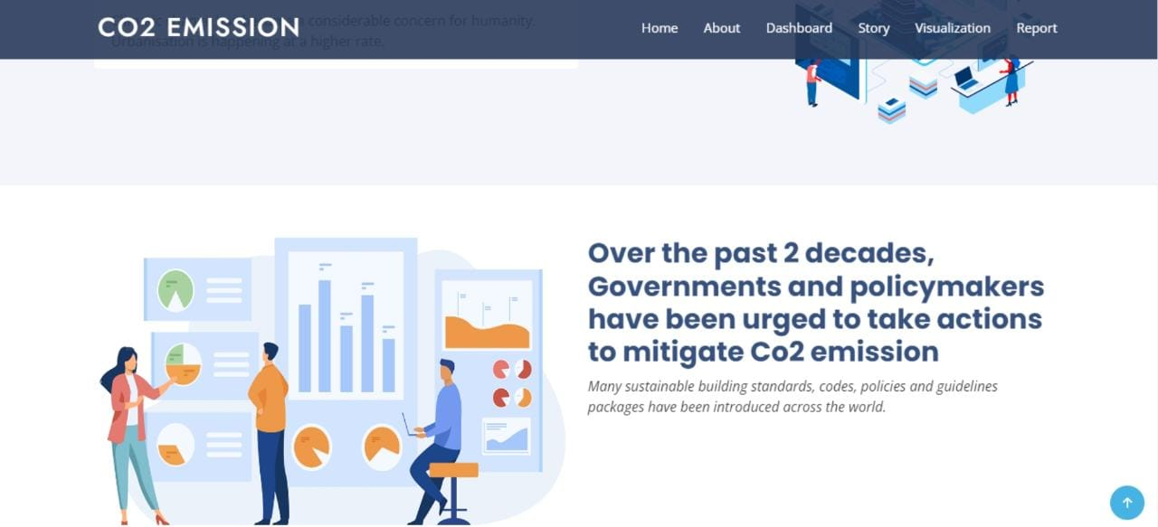

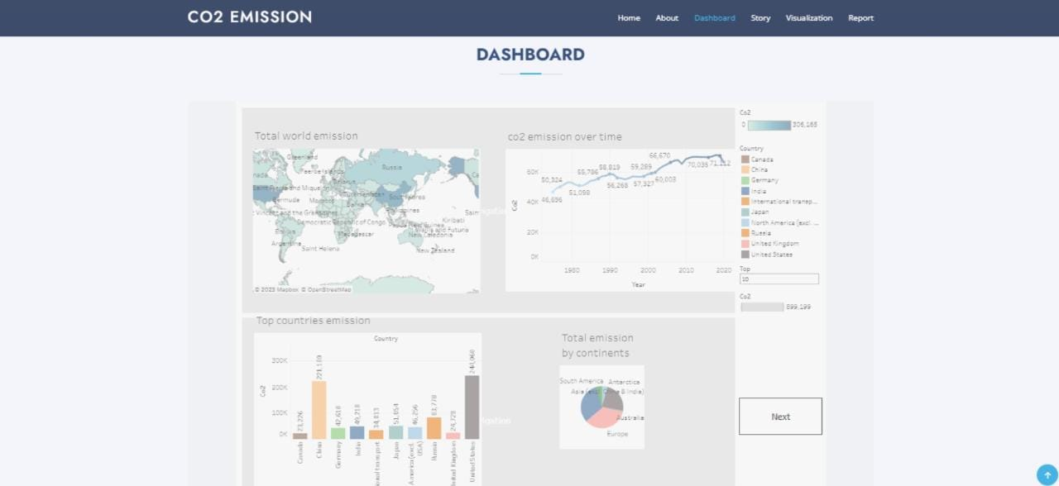

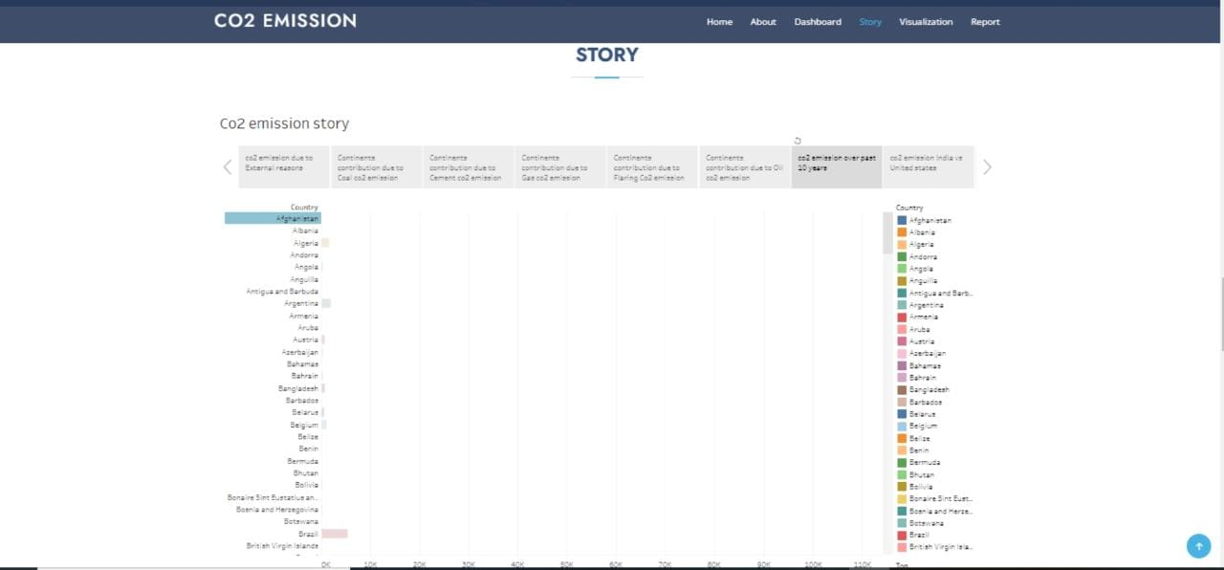

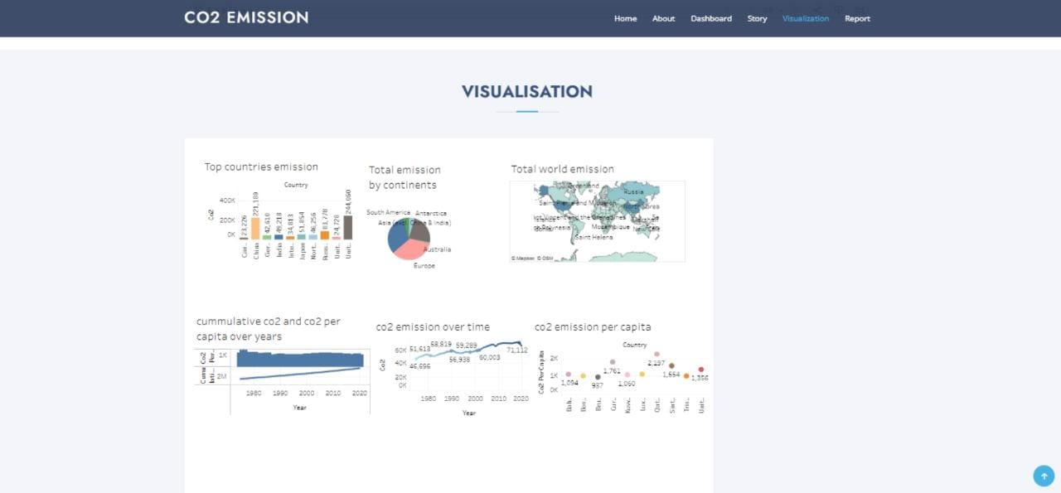

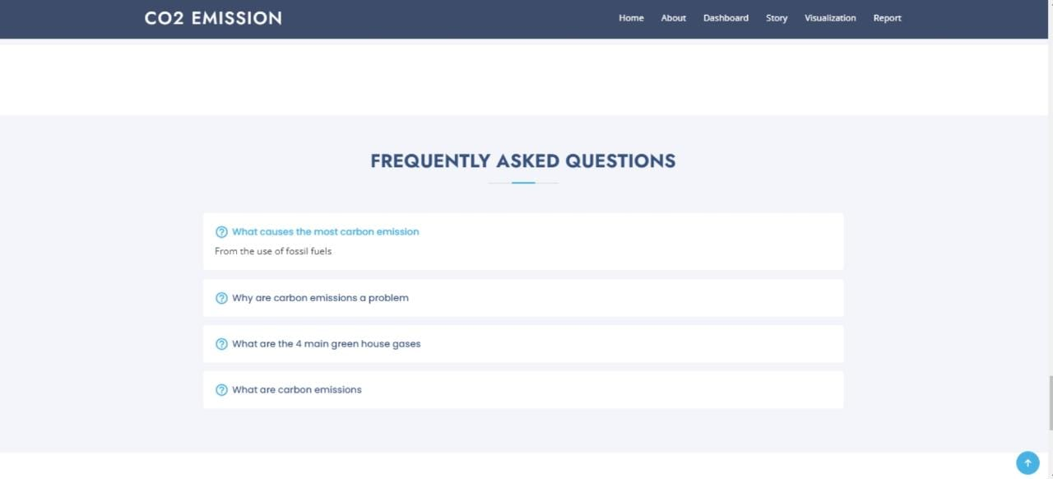

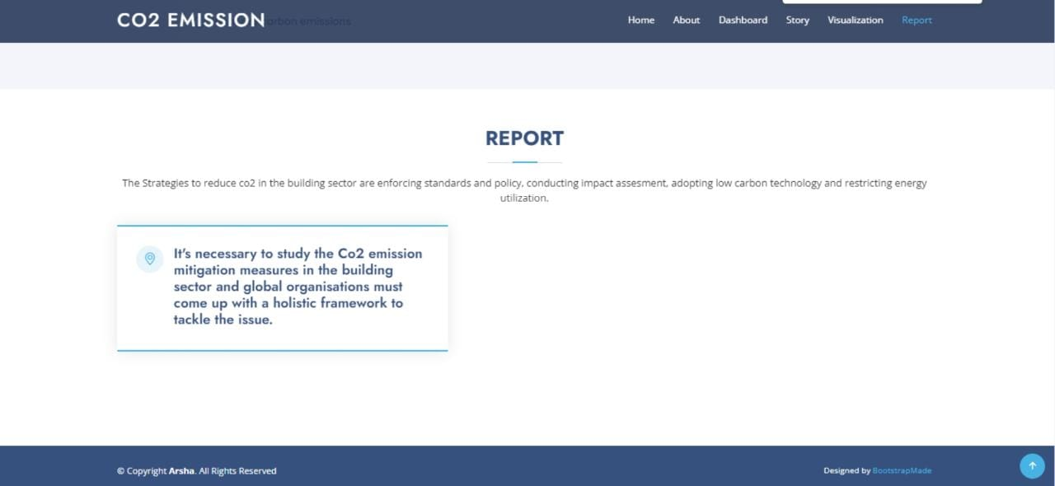

ADVANTAGES & DISADVANTAGES :-

* Cost: CO2 emission analysis can be expensive, especially for smaller businesses and organizations with limited resources. The cost of data collection, analysis, and reporting can be significant and may not be feasible for some companies.
* Complexity: Analyzing CO2 emissions can be complex and requires expertise in areas such as data analysis, energy efficiency, and environmental regulations. Small businesses or organizations may not have the expertise or resources to conduct a thorough analysis.

* Limited Scope: CO2 emission analysis typically focuses on direct emissions from a company's operations, such as from energy use and transportation. It may not capture indirect emissions from the supply chain, which can be significant in some industries.

* Uncertainty: There is often uncertainty in the data used for CO2 emission analysis. For example, it may be difficult to accurately measure emissions from certain sources or to predict how changes in operations will impact emissions.

* Limited Impact: Even if CO2 emission analysis leads to reductions in emissions, the impact may be limited in the context of global climate change. This can be discouraging for some companies, especially if they are taking steps to reduce emissions but feel like their efforts are not making a meaningful difference.

APPLICATIONS:-

* Climate change mitigation: CO2 emission analysis can help identify the sources of greenhouse gas emissions and track progress towards meeting emissions reduction targets. It can also help evaluate the effectiveness of different mitigation strategies and inform policy decisions related to climate change.

* Energy sector: CO2 emission analysis can be used to evaluate the carbon footprint of different energy sources, such as coal, oil, gas, nuclear, and renewable energy. It can also help identify opportunities to reduce emissions in the energy sector, such as improving energy efficiency, switching to renewable energy sources, and deploying carbon capture and storage technologies.

* Transportation sector: CO2 emission analysis can help assess the environmental impact of different modes of transportation, such as cars, trucks, buses, trains, and airplanes. It can also inform policy decisions related to promoting low-carbon transportation options, such as electric and hybrid vehicles, public transportation, and active transportation.

* Industrial sector: CO2 emission analysis can help identify emissions hotspots in the industrial sector, such as manufacturing plants, refineries, and chemical facilities. It can also help identify opportunities to reduce emissions through energy efficiency, process optimization, and the use of low-carbon technologies.

* Agriculture and forestry: CO2 emission analysis can help assess the impact of land use changes, such as deforestation and agricultural practices, on greenhouse gas emissions. It can also inform policies related to promoting sustainable land use practices, such as afforestation, reforestation, and sustainable agriculture.

CONCLUSION:-

* CO2 emission analysis is a critical tool for assessing the environmental impact of human activities on the climate and informing policy decisions related to climate change mitigation and adaptation. It has various applications in different sectors, including the energy sector, transportation sector, industrial sector, and agriculture and forestry. By identifying emissions hotspots and opportunities to reduce emissions through energy efficiency, renewable energy, low-carbon technologies, and sustainable land use practices, CO2 emission analysis can help us transition to a low-carbon economy and reduce our greenhouse gas emissions. Ultimately, this can help us mitigate the worst impacts of climate change and ensure a sustainable future for generations to come.

FUTURE SCOPE:-

* Improved data collection and analysis: One area for future improvement is the collection and analysis of data related to CO2 emissions. This can involve developing new data sources, improving data quality, and enhancing analytical techniques to better understand the trends and drivers of CO2 emissions.

* Integration of machine learning and AI: Machine learning and AI techniques can be used to analyze and model complex systems, such as the global climate system and energy markets, to help understand and predict future CO2 emissions.

* Scenario analysis: Scenario analysis can be used to explore the potential impacts of different policy and technology choices on CO2 emissions. This can help policymakers and businesses identify the most effective strategies for reducing emissions.

* Lifecycle analysis: In addition to analyzing CO2 emissions from individual sources, future analysis can also focus on the lifecycle emissions of products and services, from production to disposal. This can help identify opportunities to reduce emissions across the entire lifecycle of products and services.

* Carbon pricing and markets: Analysis can also focus on the design and implementation of carbon pricing mechanisms and carbon markets, which can help incentivize the reduction of CO2 emissions.

* International cooperation and coordination: Future analysis can also focus on the role of international cooperation and coordination in reducing CO2 emissions. This can involve analyzing the effectiveness of existing international agreements and exploring new models for global cooperation on climate change.

APPENDIX :-

<!DOCTYPE html>

<html lang="en">

<head>

  <meta charset="utf-8">

  <meta content="width=device-width, initial-scale=1.0" name="viewport">

  <title>Co2 Emission</title>

  <meta content="" name="description">

  <meta content="" name="keywords">

  <!-- Favicons -->

  <link href="assets/img/favicon.png" rel="icon">

  <link href="assets/img/apple-touch-icon.png" rel="apple-touch-icon">

  <!-- Google Fonts -->

  <link href="https://fonts.googleapis.com/css?family=Open+Sans:300,300i,400,400i,600,600i,700,700i|Jost:300,300i,400,400i,500,500i,600,600i,700,700i|Poppins:300,300i,400,400i,500,500i,600,600i,700,700i" rel="stylesheet">

  <!-- Vendor CSS Files -->

  <link href="assets/vendor/aos/aos.css" rel="stylesheet">

  <link href="assets/vendor/bootstrap/css/bootstrap.min.css" rel="stylesheet">

  <link href="assets/vendor/bootstrap-icons/bootstrap-icons.css" rel="stylesheet">

  <link href="assets/vendor/boxicons/css/boxicons.min.css" rel="stylesheet">

  <link href="assets/vendor/glightbox/css/glightbox.min.css" rel="stylesheet">

  <link href="assets/vendor/remixicon/remixicon.css" rel="stylesheet">

  <link href="assets/vendor/swiper/swiper-bundle.min.css" rel="stylesheet">

  <!-- Template Main CSS File -->

  <link href="assets/css/style.css" rel="stylesheet">

  <!-- =======================================================

  * Template Name: Arsha

  * Updated: Mar 10 2023 with Bootstrap v5.2.3

  * Template URL: https://bootstrapmade.com/arsha-free-bootstrap-html-template-corporate/

  * Author: BootstrapMade.com

  * License: https://bootstrapmade.com/license/

  ======================================================== -->

</head>

<body>

  <!-- ======= Header ======= -->

  <header id="header" class="fixed-top ">

    <div class="container d-flex align-items-center">

      <h1 class="logo me-auto"><a href="index.html">Co2 Emission</a></h1>

      <!-- Uncomment below if you prefer to use an image logo -->

      <!-- <a href="index.html" class="logo me-auto"><img src="assets/img/logo.png" alt="" class="img-fluid"></a>-->

      <nav id="navbar" class="navbar">

        <ul>

          <li><a class="nav-link scrollto active" href="#hero">Home</a></li>

          <li><a class="nav-link scrollto" href="#about">About</a></li>

          <li><a class="nav-link scrollto" href="#services">Dashboard</a></li>

          <li><a class="nav-link   scrollto" href="#portfolio">Story</a></li>

          <li><a class="nav-link scrollto" href="#team">Team</a></li>

          <li class="dropdown"><a href="#"><span>Drop Down</span> <i class="bi bi-chevron-down"></i></a>

            <ul>

              <li><a href="#">Drop Down 1</a></li>

              <li class="dropdown"><a href="#"><span>Deep Drop Down</span> <i class="bi bi-chevron-right"></i></a>

                <ul>

                  <li><a href="#">Deep Drop Down 1</a></li>

                  <li><a href="#">Deep Drop Down 2</a></li>

                  <li><a href="#">Deep Drop Down 3</a></li>

                  <li><a href="#">Deep Drop Down 4</a></li>

                  <li><a href="#">Deep Drop Down 5</a></li>

                </ul>

              </li>

              <li><a href="#">Drop Down 2</a></li>

              <li><a href="#">Drop Down 3</a></li>

              <li><a href="#">Drop Down 4</a></li>

            </ul>

          </li>

          <li><a class="nav-link scrollto" href="#contact">Contact</a></li>

          <li><a class="getstarted scrollto" href="#about">Get Started</a></li>

        </ul>

        <i class="bi bi-list mobile-nav-toggle"></i>

      </nav><!-- .navbar -->

    </div>

  </header><!-- End Header -->

  <!-- ======= Hero Section ======= -->

  <section id="hero" class="d-flex align-items-center">

    <div class="container">

      <div class="row">

        <div class="col-lg-6 d-flex flex-column justify-content-center pt-4 pt-lg-0 order-2 order-lg-1" data-aos="fade-up" data-aos-delay="200">

          <h1>Global Co2 emission Analysis</h1>

          <h2>Carbon dioxide emissions are the primary driver of global climate change. If's widely recognised that to avoid the worst impacts of climate change, the world needs to urgently reduce emission. z/h2>

          <div class="d-flex justify-content-center justify-content-lg-start">

            <a href="#about" class="btn-get-started scrollto">Get Started</a>

            <a href="https://www.youtube.com/watch?v=jDDaplaOz7Q" class="glightbox btn-watch-video"><i class="bi bi-play-circle"></i><span>Watch Video</span></a>

          </div>

        </div>

        <div class="col-lg-6 order-1 order-lg-2 hero-img" data-aos="zoom-in" data-aos-delay="200">

          <img src="assets/img/hero-img.png" class="img-fluid animated" alt="">

        </div>

      </div>

    </div>

  </section><!-- End Hero -->

  <main id="main">

    <!-- ======= Clients Section ======= -->

    <section id="clients" class="clients section-bg">

      <div class="container">

        <div class="row" data-aos="zoom-in">

          <div class="col-lg-2 col-md-4 col-6 d-flex align-items-center justify-content-center">

            <img src="assets/img/clients/client-1.png" class="img-fluid" alt="">

          </div>

          <div class="col-lg-2 col-md-4 col-6 d-flex align-items-center justify-content-center">

            <img src="assets/img/clients/client-2.png" class="img-fluid" alt="">

          </div>

          <div class="col-lg-2 col-md-4 col-6 d-flex align-items-center justify-content-center">

            <img src="assets/img/clients/client-3.png" class="img-fluid" alt="">

          </div>

          <div class="col-lg-2 col-md-4 col-6 d-flex align-items-center justify-content-center">

            <img src="assets/img/clients/client-4.png" class="img-fluid" alt="">

          </div>

          <div class="col-lg-2 col-md-4 col-6 d-flex align-items-center justify-content-center">

            <img src="assets/img/clients/client-5.png" class="img-fluid" alt="">

          </div>

          <div class="col-lg-2 col-md-4 col-6 d-flex align-items-center justify-content-center">

            <img src="assets/img/clients/client-6.png" class="img-fluid" alt="">

          </div>

        </div>

      </div>

    </section><!-- End Cliens Section -->

    <!-- ======= About Us Section ======= -->

    <section id="about" class="about">

      <div class="container" data-aos="fade-up">

        <div class="section-title">

          <h2>About Us</h2>

        </div>

        <div class="row content">

          <div class="col-lg-6">

            <p>

              Lorem ipsum dolor sit amet, consectetur adipiscing elit, sed do eiusmod tempor incididunt ut labore et dolore

              magna aliqua.

            </p>

            <ul>

              <li><i class="ri-check-double-line"></i> Ullamco laboris nisi ut aliquip ex ea commodo consequat</li>

              <li><i class="ri-check-double-line"></i> Duis aute irure dolor in reprehenderit in voluptate velit</li>

              <li><i class="ri-check-double-line"></i> Ullamco laboris nisi ut aliquip ex ea commodo consequat</li>

            </ul>

          </div>

          <div class="col-lg-6 pt-4 pt-lg-0">

            <p>

              Ullamco laboris nisi ut aliquip ex ea commodo consequat. Duis aute irure dolor in reprehenderit in voluptate

              velit esse cillum dolore eu fugiat nulla pariatur. Excepteur sint occaecat cupidatat non proident, sunt in

              culpa qui officia deserunt mollit anim id est laborum.

            </p>

            <a href="#" class="btn-learn-more">Learn More</a>

          </div>

        </div>

      </div>

    </section><!-- End About Us Section -->

    <!-- ======= Why Us Section ======= -->

    <section id="why-us" class="why-us section-bg">

      <div class="container-fluid" data-aos="fade-up">

        <div class="row">

          <div class="col-lg-7 d-flex flex-column justify-content-center align-items-stretch  order-2 order-lg-1">

            <div class="content">

              <h3>Eum ipsam laborum deleniti <strong>velit pariatur architecto aut nihil</strong></h3>

              <p>

                Lorem ipsum dolor sit amet, consectetur adipiscing elit, sed do eiusmod tempor incididunt ut labore et dolore magna aliqua. Duis aute irure dolor in reprehenderit

              </p>

            </div>

            <div class="accordion-list">

              <ul>

                <li>

                  <a data-bs-toggle="collapse" class="collapse" data-bs-target="#accordion-list-1"><span>01</span> Non consectetur a erat nam at lectus urna duis? <i class="bx bx-chevron-down icon-show"></i><i class="bx bx-chevron-up icon-close"></i></a>

                  <div id="accordion-list-1" class="collapse show" data-bs-parent=".accordion-list">

                    <p>

                      Feugiat pretium nibh ipsum consequat. Tempus iaculis urna id volutpat lacus laoreet non curabitur gravida. Venenatis lectus magna fringilla urna porttitor rhoncus dolor purus non.

                    </p>

                  </div>

                </li>

                <li>

                  <a data-bs-toggle="collapse" data-bs-target="#accordion-list-2" class="collapsed"><span>02</span> Feugiat scelerisque varius morbi enim nunc? <i class="bx bx-chevron-down icon-show"></i><i class="bx bx-chevron-up icon-close"></i></a>

                  <div id="accordion-list-2" class="collapse" data-bs-parent=".accordion-list">

                    <p>

                      Dolor sit amet consectetur adipiscing elit pellentesque habitant morbi. Id interdum velit laoreet id donec ultrices. Fringilla phasellus faucibus scelerisque eleifend donec pretium. Est pellentesque elit ullamcorper dignissim. Mauris ultrices eros in cursus turpis massa tincidunt dui.

                    </p>

                  </div>

                </li>

                <li>

                  <a data-bs-toggle="collapse" data-bs-target="#accordion-list-3" class="collapsed"><span>03</span> Dolor sit amet consectetur adipiscing elit? <i class="bx bx-chevron-down icon-show"></i><i class="bx bx-chevron-up icon-close"></i></a>

                  <div id="accordion-list-3" class="collapse" data-bs-parent=".accordion-list">

                    <p>

                      Eleifend mi in nulla posuere sollicitudin aliquam ultrices sagittis orci. Faucibus pulvinar elementum integer enim. Sem nulla pharetra diam sit amet nisl suscipit. Rutrum tellus pellentesque eu tincidunt. Lectus urna duis convallis convallis tellus. Urna molestie at elementum eu facilisis sed odio morbi quis

                    </p>

                  </div>

                </li>

              </ul>

            </div>

          </div>

          <div class="col-lg-5 align-items-stretch order-1 order-lg-2 img" style='background-image: url("assets/img/why-us.png");' data-aos="zoom-in" data-aos-delay="150">&nbsp;</div>

        </div>

      </div>

    </section><!-- End Why Us Section -->

    <!-- ======= Skills Section ======= -->

    <section id="skills" class="skills">

      <div class="container" data-aos="fade-up">

        <div class="row">

          <div class="col-lg-6 d-flex align-items-center" data-aos="fade-right" data-aos-delay="100">

            <img src="assets/img/skills.png" class="img-fluid" alt="">

          </div>

          <div class="col-lg-6 pt-4 pt-lg-0 content" data-aos="fade-left" data-aos-delay="100">

            <h3>Voluptatem dignissimos provident quasi corporis voluptates</h3>

            <p class="fst-italic">

              Lorem ipsum dolor sit amet, consectetur adipiscing elit, sed do eiusmod tempor incididunt ut labore et dolore

              magna aliqua.

            </p>

            <div class="skills-content">

              <div class="progress">

                <span class="skill">HTML <i class="val">100%</i></span>

                <div class="progress-bar-wrap">

                  <div class="progress-bar" role="progressbar" aria-valuenow="100" aria-valuemin="0" aria-valuemax="100"></div>

                </div>

              </div>

              <div class="progress">

                <span class="skill">CSS <i class="val">90%</i></span>

                <div class="progress-bar-wrap">

                  <div class="progress-bar" role="progressbar" aria-valuenow="90" aria-valuemin="0" aria-valuemax="100"></div>

                </div>

              </div>

              <div class="progress">

                <span class="skill">JavaScript <i class="val">75%</i></span>

                <div class="progress-bar-wrap">

                  <div class="progress-bar" role="progressbar" aria-valuenow="75" aria-valuemin="0" aria-valuemax="100"></div>

                </div>

              </div>

              <div class="progress">

                <span class="skill">Photoshop <i class="val">55%</i></span>

                <div class="progress-bar-wrap">

                  <div class="progress-bar" role="progressbar" aria-valuenow="55" aria-valuemin="0" aria-valuemax="100"></div>

                </div>

              </div>

            </div>

          </div>

        </div>

      </div>

    </section><!-- End Skills Section -->

    <!-- ======= Services Section ======= -->

    <section id="services" class="services section-bg">

      <div class="container" data-aos="fade-up">

        <div class="section-title">

          <h2>Dashboard</h2>

        </div>

        <div class='tableauPlaceholder' id='viz1681105011382' style='position: relative'><noscript><a href='#'><img alt='Dashboard 1 ' src='https:&#47;&#47;public.tableau.com&#47;static&#47;images&#47;Co&#47;Co2emissionDashboard_16811003334890&#47;Dashboard1&#47;1_rss.png' style='border: none' /></a></noscript><object class='tableauViz'  style='display:none;'><param name='host_url' value='https%3A%2F%2Fpublic.tableau.com%2F' /> <param name='embed_code_version' value='3' /> <param name='site_root' value='' /><param name='name' value='Co2emissionDashboard_16811003334890&#47;Dashboard1' /><param name='tabs' value='no' /><param name='toolbar' value='yes' /><param name='static_image' value='https:&#47;&#47;public.tableau.com&#47;static&#47;images&#47;Co&#47;Co2emissionDashboard_16811003334890&#47;Dashboard1&#47;1.png' /> <param name='animate_transition' value='yes' /><param name='display_static_image' value='yes' /><param name='display_spinner' value='yes' /><param name='display_overlay' value='yes' /><param name='display_count' value='yes' /><param name='language' value='en-US' /></object></div>                <script type='text/javascript'>                    var divElement = document.getElementById('viz1681105011382');                    var vizElement = divElement.getElementsByTagName('object')[0];                    if ( divElement.offsetWidth > 800 ) { vizElement.style.width='100%';vizElement.style.height=(divElement.offsetWidth*0.75)+'px';} else if ( divElement.offsetWidth > 500 ) { vizElement.style.width='100%';vizElement.style.height=(divElement.offsetWidth*0.75)+'px';} else { vizElement.style.width='100%';vizElement.style.height='1677px';}                     var scriptElement = document.createElement('script');                    scriptElement.src = 'https://public.tableau.com/javascripts/api/viz_v1.js';                    vizElement.parentNode.insertBefore(scriptElement, vizElement);                </script>

      </div>

    </section><!-- End Services Section -->

    <!-- ======= Cta Section ======= -->

    <section id="cta" class="cta">

      <div class="container" data-aos="zoom-in">

        <div class="row">

          <div class="col-lg-9 text-center text-lg-start">

            <h3>Call To Action</h3>

            <p> Duis aute irure dolor in reprehenderit in voluptate velit esse cillum dolore eu fugiat nulla pariatur. Excepteur sint occaecat cupidatat non proident, sunt in culpa qui officia deserunt mollit anim id est laborum.</p>

          </div>

          <div class="col-lg-3 cta-btn-container text-center">

            <a class="cta-btn align-middle" href="#">Call To Action</a>

          </div>

        </div>

      </div>

    </section><!-- End Cta Section -->

    <!-- ======= Portfolio Section ======= -->

    <section id="portfolio" class="portfolio">

      <div class="container" data-aos="fade-up">

        <div class="section-title">

          <h2>Story</h2>

          </div>

          <div class='tableauPlaceholder' id='viz1681105925835' style='position: relative'><noscript><a href='#'><img alt='Co2 emission story ' src='https:&#47;&#47;public.tableau.com&#47;static&#47;images&#47;Co&#47;Co2emissionStory&#47;Co2emissionstory&#47;1_rss.png' style='border: none' /></a></noscript><object class='tableauViz'  style='display:none;'><param name='host_url' value='https%3A%2F%2Fpublic.tableau.com%2F' /> <param name='embed_code_version' value='3' /> <param name='site_root' value='' /><param name='name' value='Co2emissionStory&#47;Co2emissionstory' /><param name='tabs' value='no' /><param name='toolbar' value='yes' /><param name='static_image' value='https:&#47;&#47;public.tableau.com&#47;static&#47;images&#47;Co&#47;Co2emissionStory&#47;Co2emissionstory&#47;1.png' /> <param name='animate_transition' value='yes' /><param name='display_static_image' value='yes' /><param name='display_spinner' value='yes' /><param name='display_overlay' value='yes' /><param name='display_count' value='yes' /><param name='language' value='en-US' /><param name='filter' value='publish=yes' /></object></div>                <script type='text/javascript'>                    var divElement = document.getElementById('viz1681105925835');                    var vizElement = divElement.getElementsByTagName('object')[0];                    vizElement.style.width='100%';vizElement.style.height=(divElement.offsetWidth*0.75)+'px';                    var scriptElement = document.createElement('script');                    scriptElement.src = 'https://public.tableau.com/javascripts/api/viz_v1.js';                    vizElement.parentNode.insertBefore(scriptElement, vizElement);                </script>

      </div>

    </section><!-- End Portfolio Section -->

    <!-- ======= Team Section ======= -->

    <section id="team" class="team section-bg">

      <div class="container" data-aos="fade-up">

        <div class="section-title">

          <h2>Visualisation</h2>

           </div>

           <div class='tableauPlaceholder' id='viz1681109275518' style='position: relative'><noscript><a href='#'><img alt='Dashboard 4 ' src='https:&#47;&#47;public.tableau.com&#47;static&#47;images&#47;Co&#47;Co2emissionVisualisation&#47;Dashboard4&#47;1_rss.png' style='border: none' /></a></noscript><object class='tableauViz'  style='display:none;'><param name='host_url' value='https%3A%2F%2Fpublic.tableau.com%2F' /> <param name='embed_code_version' value='3' /> <param name='site_root' value='' /><param name='name' value='Co2emissionVisualisation&#47;Dashboard4' /><param name='tabs' value='no' /><param name='toolbar' value='yes' /><param name='static_image' value='https:&#47;&#47;public.tableau.com&#47;static&#47;images&#47;Co&#47;Co2emissionVisualisation&#47;Dashboard4&#47;1.png' /> <param name='animate_transition' value='yes' /><param name='display_static_image' value='yes' /><param name='display_spinner' value='yes' /><param name='display_overlay' value='yes' /><param name='display_count' value='yes' /><param name='language' value='en-US' /><param name='filter' value='publish=yes' /></object></div>                <script type='text/javascript'>                    var divElement = document.getElementById('viz1681109275518');                    var vizElement = divElement.getElementsByTagName('object')[0];                    if ( divElement.offsetWidth > 800 ) { vizElement.style.width='1000px';vizElement.style.height='827px';} else if ( divElement.offsetWidth > 500 ) { vizElement.style.width='1000px';vizElement.style.height='827px';} else { vizElement.style.width='100%';vizElement.style.height='1427px';}                     var scriptElement = document.createElement('script');                    scriptElement.src = 'https://public.tableau.com/javascripts/api/viz_v1.js';                    vizElement.parentNode.insertBefore(scriptElement, vizElement);                </script>

      </div>

    </section><!-- End Team Section -->

    <!-- ======= Pricing Section ======= -->

    <section id="pricing" class="pricing">

      <div class="container" data-aos="fade-up">

        <div class="section-title">

          <h2>Pricing</h2>

          </div>

        <div class="row">

          <div class="col-lg-4" data-aos="fade-up" data-aos-delay="100">

            <div class="box">

              <h3>Free Plan</h3>

              <h4><sup>$</sup>0<span>per month</span></h4>

              <ul>

                <li><i class="bx bx-check"></i> Quam adipiscing vitae proin</li>

                <li><i class="bx bx-check"></i> Nec feugiat nisl pretium</li>

                <li><i class="bx bx-check"></i> Nulla at volutpat diam uteera</li>

                <li class="na"><i class="bx bx-x"></i> <span>Pharetra massa massa ultricies</span></li>

                <li class="na"><i class="bx bx-x"></i> <span>Massa ultricies mi quis hendrerit</span></li>

              </ul>

              <a href="#" class="buy-btn">Get Started</a>

            </div>

          </div>

          <div class="col-lg-4 mt-4 mt-lg-0" data-aos="fade-up" data-aos-delay="200">

            <div class="box featured">

              <h3>Business Plan</h3>

              <h4><sup>$</sup>29<span>per month</span></h4>

              <ul>

                <li><i class="bx bx-check"></i> Quam adipiscing vitae proin</li>

                <li><i class="bx bx-check"></i> Nec feugiat nisl pretium</li>

                <li><i class="bx bx-check"></i> Nulla at volutpat diam uteera</li>

                <li><i class="bx bx-check"></i> Pharetra massa massa ultricies</li>

                <li><i class="bx bx-check"></i> Massa ultricies mi quis hendrerit</li>

              </ul>

              <a href="#" class="buy-btn">Get Started</a>

            </div>

          </div>

          <div class="col-lg-4 mt-4 mt-lg-0" data-aos="fade-up" data-aos-delay="300">

            <div class="box">

              <h3>Developer Plan</h3>

              <h4><sup>$</sup>49<span>per month</span></h4>

              <ul>

                <li><i class="bx bx-check"></i> Quam adipiscing vitae proin</li>

                <li><i class="bx bx-check"></i> Nec feugiat nisl pretium</li>

                <li><i class="bx bx-check"></i> Nulla at volutpat diam uteera</li>

                <li><i class="bx bx-check"></i> Pharetra massa massa ultricies</li>

                <li><i class="bx bx-check"></i> Massa ultricies mi quis hendrerit</li>

              </ul>

              <a href="#" class="buy-btn">Get Started</a>

            </div>

          </div>

        </div>

      </div>

    </section><!-- End Pricing Section -->

    <!-- ======= Frequently Asked Questions Section ======= -->

    <section id="faq" class="faq section-bg">

      <div class="container" data-aos="fade-up">

        <div class="section-title">

          <h2>Frequently Asked Questions</h2>

          <p>Magnam dolores commodi suscipit. Necessitatibus eius consequatur ex aliquid fuga eum quidem. Sit sint consectetur velit. Quisquam quos quisquam cupiditate. Et nemo qui impedit suscipit alias ea. Quia fugiat sit in iste officiis commodi quidem hic quas.</p>

        </div>

        <div class="faq-list">

          <ul>

            <li data-aos="fade-up" data-aos-delay="100">

              <i class="bx bx-help-circle icon-help"></i> <a data-bs-toggle="collapse" class="collapse" data-bs-target="#faq-list-1">Non consectetur a erat nam at lectus urna duis? <i class="bx bx-chevron-down icon-show"></i><i class="bx bx-chevron-up icon-close"></i></a>

              <div id="faq-list-1" class="collapse show" data-bs-parent=".faq-list">

                <p>

                  Feugiat pretium nibh ipsum consequat. Tempus iaculis urna id volutpat lacus laoreet non curabitur gravida. Venenatis lectus magna fringilla urna porttitor rhoncus dolor purus non.

                </p>

              </div>

            </li>

            <li data-aos="fade-up" data-aos-delay="200">

              <i class="bx bx-help-circle icon-help"></i> <a data-bs-toggle="collapse" data-bs-target="#faq-list-2" class="collapsed">Feugiat scelerisque varius morbi enim nunc? <i class="bx bx-chevron-down icon-show"></i><i class="bx bx-chevron-up icon-close"></i></a>

              <div id="faq-list-2" class="collapse" data-bs-parent=".faq-list">

                <p>

                  Dolor sit amet consectetur adipiscing elit pellentesque habitant morbi. Id interdum velit laoreet id donec ultrices. Fringilla phasellus faucibus scelerisque eleifend donec pretium. Est pellentesque elit ullamcorper dignissim. Mauris ultrices eros in cursus turpis massa tincidunt dui.

                </p>

              </div>

            </li>

            <li data-aos="fade-up" data-aos-delay="300">

              <i class="bx bx-help-circle icon-help"></i> <a data-bs-toggle="collapse" data-bs-target="#faq-list-3" class="collapsed">Dolor sit amet consectetur adipiscing elit? <i class="bx bx-chevron-down icon-show"></i><i class="bx bx-chevron-up icon-close"></i></a>

              <div id="faq-list-3" class="collapse" data-bs-parent=".faq-list">

                <p>

                  Eleifend mi in nulla posuere sollicitudin aliquam ultrices sagittis orci. Faucibus pulvinar elementum integer enim. Sem nulla pharetra diam sit amet nisl suscipit. Rutrum tellus pellentesque eu tincidunt. Lectus urna duis convallis convallis tellus. Urna molestie at elementum eu facilisis sed odio morbi quis

                </p>

              </div>

            </li>

            <li data-aos="fade-up" data-aos-delay="400">

              <i class="bx bx-help-circle icon-help"></i> <a data-bs-toggle="collapse" data-bs-target="#faq-list-4" class="collapsed">Tempus quam pellentesque nec nam aliquam sem et tortor consequat? <i class="bx bx-chevron-down icon-show"></i><i class="bx bx-chevron-up icon-close"></i></a>

              <div id="faq-list-4" class="collapse" data-bs-parent=".faq-list">

                <p>

                  Molestie a iaculis at erat pellentesque adipiscing commodo. Dignissim suspendisse in est ante in. Nunc vel risus commodo viverra maecenas accumsan. Sit amet nisl suscipit adipiscing bibendum est. Purus gravida quis blandit turpis cursus in.

                </p>

              </div>

            </li>

            <li data-aos="fade-up" data-aos-delay="500">

              <i class="bx bx-help-circle icon-help"></i> <a data-bs-toggle="collapse" data-bs-target="#faq-list-5" class="collapsed">Tortor vitae purus faucibus ornare. Varius vel pharetra vel turpis nunc eget lorem dolor? <i class="bx bx-chevron-down icon-show"></i><i class="bx bx-chevron-up icon-close"></i></a>

              <div id="faq-list-5" class="collapse" data-bs-parent=".faq-list">

                <p>

                  Laoreet sit amet cursus sit amet dictum sit amet justo. Mauris vitae ultricies leo integer malesuada nunc vel. Tincidunt eget nullam non nisi est sit amet. Turpis nunc eget lorem dolor sed. Ut venenatis tellus in metus vulputate eu scelerisque.

                </p>

              </div>

            </li>

          </ul>

        </div>

      </div>

    </section><!-- End Frequently Asked Questions Section -->

    <!-- ======= Contact Section ======= -->

    <section id="contact" class="contact">

      <div class="container" data-aos="fade-up">

        <div class="section-title">

          <h2>Contact</h2>

          <p>Magnam dolores commodi suscipit. Necessitatibus eius consequatur ex aliquid fuga eum quidem. Sit sint consectetur velit. Quisquam quos quisquam cupiditate. Et nemo qui impedit suscipit alias ea. Quia fugiat sit in iste officiis commodi quidem hic quas.</p>

        </div>

        <div class="row">

          <div class="col-lg-5 d-flex align-items-stretch">

            <div class="info">

              <div class="address">

                <i class="bi bi-geo-alt"></i>

                <h4>Location:</h4>

                <p>A108 Adam Street, New York, NY 535022</p>

              </div>

              <div class="email">

                <i class="bi bi-envelope"></i>

                <h4>Email:</h4>

                <p>info@example.com</p>

              </div>

              <div class="phone">

                <i class="bi bi-phone"></i>

                <h4>Call:</h4>

                <p>+1 5589 55488 55s</p>

              </div>

              <iframe src="https://www.google.com/maps/embed?pb=!1m14!1m8!1m3!1d12097.433213460943!2d-74.0062269!3d40.7101282!3m2!1i1024!2i768!4f13.1!3m3!1m2!1s0x0%3A0xb89d1fe6bc499443!2sDowntown+Conference+Center!5e0!3m2!1smk!2sbg!4v1539943755621" frameborder="0" style="border:0; width: 100%; height: 290px;" allowfullscreen></iframe>

            </div>

          </div>

          <div class="col-lg-7 mt-5 mt-lg-0 d-flex align-items-stretch">

            <form action="forms/contact.php" method="post" role="form" class="php-email-form">

              <div class="row">

                <div class="form-group col-md-6">

                  <label for="name">Your Name</label>

                  <input type="text" name="name" class="form-control" id="name" required>

                </div>

                <div class="form-group col-md-6">

                  <label for="name">Your Email</label>

                  <input type="email" class="form-control" name="email" id="email" required>

                </div>

              </div>

              <div class="form-group">

                <label for="name">Subject</label>

                <input type="text" class="form-control" name="subject" id="subject" required>

              </div>

              <div class="form-group">

                <label for="name">Message</label>

                <textarea class="form-control" name="message" rows="10" required></textarea>

              </div>

              <div class="my-3">

                <div class="loading">Loading</div>

                <div class="error-message"></div>

                <div class="sent-message">Your message has been sent. Thank you!</div>

              </div>

              <div class="text-center"><button type="submit">Send Message</button></div>

            </form>

          </div>

        </div>

      </div>

    </section><!-- End Contact Section -->

  </main><!-- End #main -->

  <!-- ======= Footer ======= -->

  <footer id="footer">

    <div class="footer-newsletter">

      <div class="container">

        <div class="row justify-content-center">

          <div class="col-lg-6">

            <h4>Join Our Newsletter</h4>

            <p>Tamen quem nulla quae legam multos aute sint culpa legam noster magna</p>

            <form action="" method="post">

              <input type="email" name="email"><input type="submit" value="Subscribe">

            </form>

          </div>

        </div>

      </div>

    </div>

    <div class="footer-top">

      <div class="container">

        <div class="row">

          <div class="col-lg-3 col-md-6 footer-contact">

            <h3>Arsha</h3>

            <p>

              A108 Adam Street <br>

              New York, NY 535022<br>

              United States <br><br>

              <strong>Phone:</strong> +1 5589 55488 55<br>

              <strong>Email:</strong> info@example.com<br>

            </p>

          </div>

          <div class="col-lg-3 col-md-6 footer-links">

            <h4>Useful Links</h4>

            <ul>

              <li><i class="bx bx-chevron-right"></i> <a href="#">Home</a></li>

              <li><i class="bx bx-chevron-right"></i> <a href="#">About us</a></li>

              <li><i class="bx bx-chevron-right"></i> <a href="#">Services</a></li>

              <li><i class="bx bx-chevron-right"></i> <a href="#">Terms of service</a></li>

              <li><i class="bx bx-chevron-right"></i> <a href="#">Privacy policy</a></li>

            </ul>

          </div>

          <div class="col-lg-3 col-md-6 footer-links">

            <h4>Our Services</h4>

            <ul>

              <li><i class="bx bx-chevron-right"></i> <a href="#">Web Design</a></li>

              <li><i class="bx bx-chevron-right"></i> <a href="#">Web Development</a></li>

              <li><i class="bx bx-chevron-right"></i> <a href="#">Product Management</a></li>

              <li><i class="bx bx-chevron-right"></i> <a href="#">Marketing</a></li>

              <li><i class="bx bx-chevron-right"></i> <a href="#">Graphic Design</a></li>

            </ul>

          </div>

          <div class="col-lg-3 col-md-6 footer-links">

            <h4>Our Social Networks</h4>

            <p>Cras fermentum odio eu feugiat lide par naso tierra videa magna derita valies</p>

            <div class="social-links mt-3">

              <a href="#" class="twitter"><i class="bx bxl-twitter"></i></a>

              <a href="#" class="facebook"><i class="bx bxl-facebook"></i></a>

              <a href="#" class="instagram"><i class="bx bxl-instagram"></i></a>

              <a href="#" class="google-plus"><i class="bx bxl-skype"></i></a>

              <a href="#" class="linkedin"><i class="bx bxl-linkedin"></i></a>

            </div>

          </div>

        </div>

      </div>

    </div>

    <div class="container footer-bottom clearfix">

      <div class="copyright">

        &copy; Copyright <strong><span>Arsha</span></strong>. All Rights Reserved

      </div>

      <div class="credits">

        <!-- All the links in the footer should remain intact. -->

        <!-- You can delete the links only if you purchased the pro version. -->

        <!-- Licensing information: https://bootstrapmade.com/license/ -->

        <!-- Purchase the pro version with working PHP/AJAX contact form: https://bootstrapmade.com/arsha-free-bootstrap-html-template-corporate/ -->

        Designed by <a href="https://bootstrapmade.com/">BootstrapMade</a>

      </div>

    </div>

  </footer><!-- End Footer -->

  <div id="preloader"></div>

  <a href="#" class="back-to-top d-flex align-items-center justify-content-center"><i class="bi bi-arrow-up-short"></i></a>

  <!-- Vendor JS Files -->

  <script src="assets/vendor/aos/aos.js"></script>

  <script src="assets/vendor/bootstrap/js/bootstrap.bundle.min.js"></script>

  <script src="assets/vendor/glightbox/js/glightbox.min.js"></script>

  <script src="assets/vendor/isotope-layout/isotope.pkgd.min.js"></script>

  <script src="assets/vendor/swiper/swiper-bundle.min.js"></script>

  <script src="assets/vendor/waypoints/noframework.waypoints.js"></script>

  <script src="assets/vendor/php-email-form/validate.js"></script>

  <!-- Template Main JS File -->

  <script src="assets/js/main.js"></script>

</body>

</html>